

**Government Polytechnic Jalgaon**

Academic Year 2019-20

Course Code

Digital Techniques(22230)

EJ 3 I.

TITLE

To study Design And Implementation Of Half Adder And Half Subtractor.

Submmited By :-

1. Prathamesh Saraf (13)

2. Rohit Koli (14)

3. Tushar Rathod (15)

4. Hiten Mahajan (16)

**Under the guidance of:**

**MR C.R.bharhate(sir)**

**Rational :-**

In the present scenariomost of the electronics equipment like computers , mobiles , music systems , ATM , automation and control circuit and systems are based on digital circuit which the diploma electronics engineering passout (also called technologists) have to test them .

The knowleged of basic logic gate , combinational and sequencial logic circuits using discrete gates well as digital ics will enable the student to interpreat the working of equipment and maintain them. After completion of the course , students will be able to develop digital circuits based application .



**MAHARASHTRA STATE BOARD OF TECHNICAL EDUCATION**

**Certificate**

This is to certify that Mr/Ms.**Prathamesh, Rohit , Tushar , Hiten ,** Roll No.**13,14,15,16** Of **3rd** Semester of Diploma in **E&TC.** of Institute, **Government Polytechnic, Jalgaon** (Code:0018/1567) has completed the **Micro Project** satisfactorily in the Subject –  **digital electronic (22320)** for the Academic Year 2019- 2020 as prescribed in the curriculum.

Place**: Jalgaon** Enrollment No:-

**1800180265,1800180….,1800180….. , 1800180…. , 1800180……**

Date:-

Exam. Seat No:-

**Subject Teacher Head of the Department Principal**

**Subtractor :-**

The subtractor of two binary numbers can be done by taking the complement of the subtrahend and adding it to minuend .

The rules of subtracor of binary subtraction are as follows:

0 – 0 = 0

0 – 1 = 1 (borrow=1)

1 – 0 = 1

1 – 1 = 0

There are two types of binary subtractors :

1. Half subtractor
2. Full subtractor

**1 Half subtractor :-**

The half subtractor is a combinational circuit with two inputs and two outputs.

**Block diagram:-**

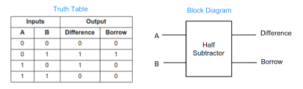

**Truth table :-**

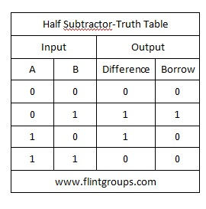

**K map:-**

1. For difference :-

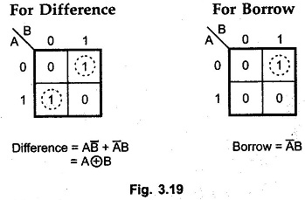



1. For borrow :-





**Logic diagram :-**

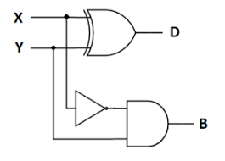

**Application of Half Subtractor:-**

The applications of half subtractor include the following.

* Half subtractor is used to reduce the force of audio or radio signals
* It can be [used in amplifiers](https://www.elprocus.com/classification-of-amplifiers-classes-its-applications/) to reduce the sound distortion
* Half subtractor is [used in ALU of processor](https://www.elprocus.com/evolution-of-microprocessor-with-applications/)
* It can be used to increase and decrease operators and also calculates the addresses
* Half subtractor is used to subtract the least significant column numbers. For subtraction of multi-digit numbers, it can be used for the LSB.

**2. Full subtractor**

The full subtractor is a combination circuit which performs subtraction between two bits considering that a 1 has been borrowed from the previous stage.

**Block diagram:-**

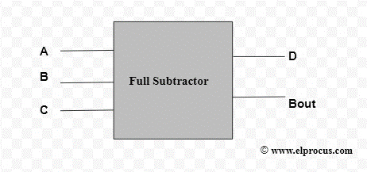

**Truth table :-**

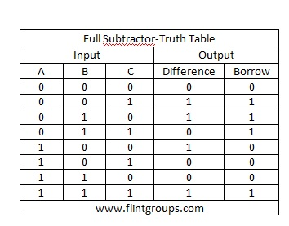

**Kmap**:-

For difference :-

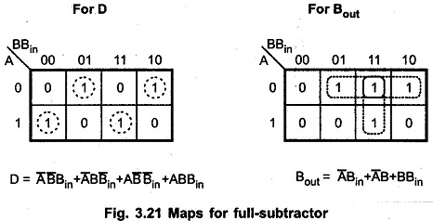

For barrow:-



**Logic diagram**

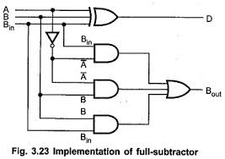

**Application of full subtractor :-**

* These are generally employed for ALU (Arithmetic logic unit) in computers to subtract as CPU & GPU for the applications of graphics to decrease the circuit difficulty.
* Subtractors are mostly used for performing arithmetical functions like subtraction, in electronic calculators as well as digital devices.
* These are also applicable for [different microcontrollers](https://www.elprocus.com/different-microcontrollers-used-in-automobiles/) for arithmetic subtraction, timers, and program counter (PC)
* Subtractors are used in processors to compute tables, address, etc.
* It is also useful for DSP and networking based systems.